# KPI’s

PIZZA SALES SQL QUERIES

## Total Revenue:

SELECT SUM(total_price) AS Total_Revenue FROM pizza_sales;

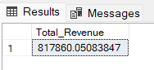

## Average Order Value

SELECT (SUM(total_price) / COUNT(DISTINCT order_id)) AS Avg_order_Value FROM pizza_sales

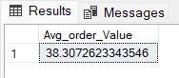

## Total Pizzas Sold

SELECT SUM(quantity) AS Total_pizza_sold FROM pizza_sales

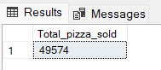

## Total Orders

SELECT COUNT(DISTINCT order_id) AS Total_Orders FROM pizza_sales

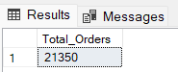

## Average Pizzas Per Order

SELECT CAST(CAST(SUM(quantity) AS DECIMAL(10,2)) / CAST(COUNT(DISTINCT order_id) AS DECIMAL(10,2)) AS DECIMAL(10,2))

AS Avg_Pizzas_per_order FROM pizza_sales

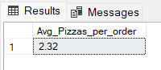

# Hourly Trend for Total Pizzas Sold

SELECT DATEPART(HOUR, order_time) as order_hours, SUM(quantity) as total_pizzas_sold

from pizza_sales

group by DATEPART(HOUR, order_time) order by DATEPART(HOUR, order_time)

***Output***

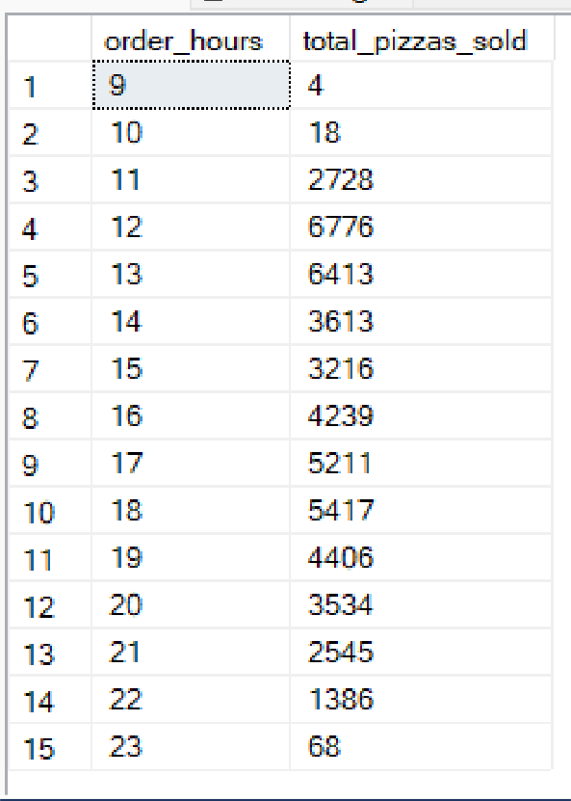

# Weekly Trend for Orders

SELECT

DATEPART(ISO_WEEK, order_date) AS WeekNumber, YEAR(order_date) AS Year,

COUNT(DISTINCT order_id) AS Total_orders FROM

pizza_sales GROUP BY

DATEPART(ISO_WEEK, order_date), YEAR(order_date)

ORDER BY

Year, WeekNumber;

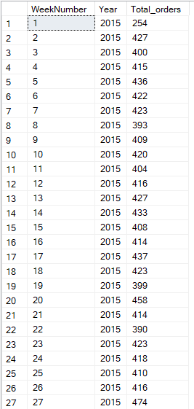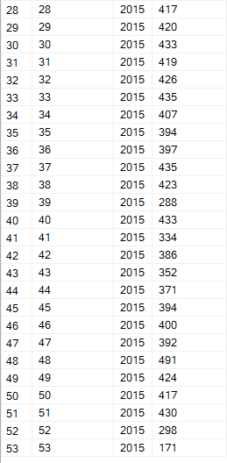

# % of Sales by Pizza Category

SELECT pizza_category, CAST(SUM(total_price) AS DECIMAL(10,2)) as total_revenue,

CAST(SUM(total_price) * 100 / (SELECT SUM(total_price) from pizza_sales) AS DECIMAL(10,2)) AS PCT

FROM pizza_sales

GROUP BY pizza_category

***Output***

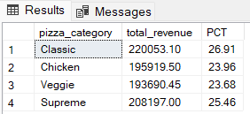

# % of Sales by Pizza Size

SELECT pizza_size, CAST(SUM(total_price) AS DECIMAL(10,2)) as total_revenue,

CAST(SUM(total_price) * 100 / (SELECT SUM(total_price) from pizza_sales) AS DECIMAL(10,2)) AS PCT

FROM pizza_sales GROUP BY pizza_size ORDER BY pizza_size

***Output***

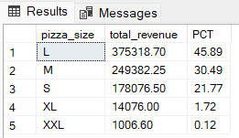

# Total Pizzas Sold by Pizza Category

SELECT pizza_category, SUM(quantity) as Total_Quantity_Sold FROM pizza_sales

WHERE MONTH(order_date) = 2 GROUP BY pizza_category

ORDER BY Total_Quantity_Sold DESC

***Output***

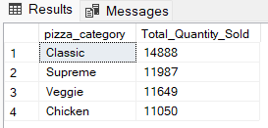

# Top 5 Pizzas by Revenue

SELECT Top 5 pizza_name, SUM(total_price) AS Total_Revenue FROM pizza_sales

GROUP BY pizza_name

ORDER BY Total_Revenue DESC

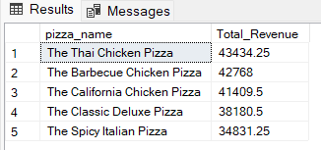

# Bottom 5 Pizzas by Revenue

SELECT Top 5 pizza_name, SUM(total_price) AS Total_Revenue FROM pizza_sales

GROUP BY pizza_name

ORDER BY Total_Revenue ASC

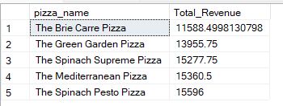

# Top 5 Pizzas by Quantity

SELECT Top 5 pizza_name, SUM(quantity) AS Total_Pizza_Sold FROM pizza_sales

GROUP BY pizza_name

ORDER BY Total_Pizza_Sold DESC

***Output***

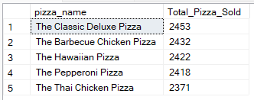

# Bottom 5 Pizzas by Quantity

SELECT TOP 5 pizza_name, SUM(quantity) AS Total_Pizza_Sold

FROM pizza_sales GROUP BY pizza_name

ORDER BY Total_Pizza_Sold ASC

***Output***

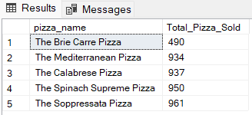

# Top 5 Pizzas by Total Orders

SELECT Top 5 pizza_name, COUNT(DISTINCT order_id) AS Total_Orders FROM pizza_sales

GROUP BY pizza_name

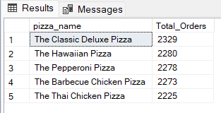ORDER BY Total_Orders DESC

# Bottom 5 Pizzas by Total Orders

SELECT Top 5 pizza_name, COUNT(DISTINCT order_id) AS Total_Orders FROM pizza_sales

GROUP BY pizza_name

ORDER BY Total_Orders ASC

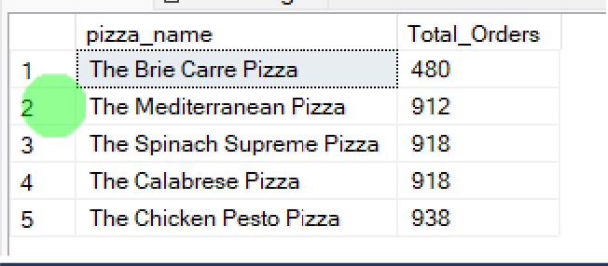

***NOTE***

If you want to apply the pizza_category or pizza_size filters to the above queries you can use WHERE clause. Follow some of below examples

SELECT Top 5 pizza_name, COUNT(DISTINCT order_id) AS Total_Orders FROM pizza_sales

WHERE pizza_category = 'Classic' GROUP BY pizza_name

ORDER BY Total_Orders ASC